

***University of Buckets***

Player Agreement

**September 04, 2021**

# Overview

Thank you for giving us the opportunity to work with you and help develop your basketball and most important life skills! We will be expecting more from you than any other program has! This is a BOOT-CAMP for Basketball where we expect you to spend most of your time and energy on studying the game. During this time with us you will be in the gym, weight room as well as alternate exercises. All of the activities are required to be done whether in-group or on your own we expect you to hold yourself accountable. This will be a very different situation for all parties involved in the sense of how much we work and how we work. We believe in teaching a high pace, run and gun offense and full court pressing all game. We will be rotating on a schedule so you don’t get pulled for doing something wrong. You play as hard as you can and then the next group comes in to create a wave of energy that doesn’t slow down. Joe Cairo will be going over our on court cardio work, as well as our overall defensive and offensive schemes. Avery Sharer will be helping with personal skill-sets creating plays, and motivational counseling as well as coach if needed. Our goal is to prepare you to play at the next level and the first part of that is physical strength and stamina. We plan to teach you the actual amount of time, effort and energy needed to be a part of this game at the next level.

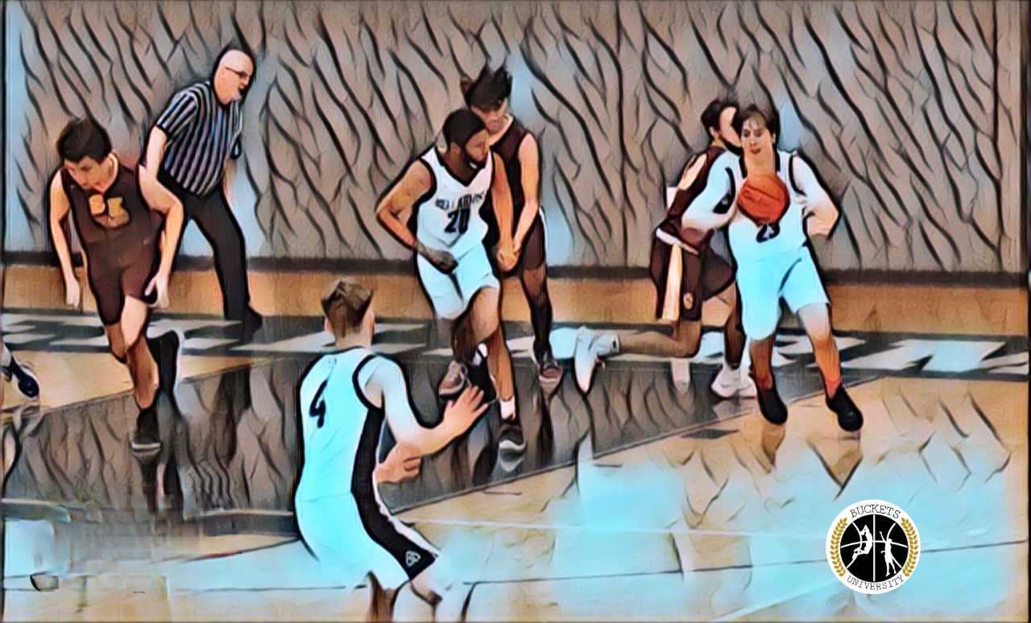

# Goals

1. **Pro Level Offensive Bag:** Every player needs to be able to have confidence and understand how to score on at least 3 of the 4 Tiers (3’s, Mid-range, driving and post moves). We will be spending many hours on how and what is needed to be a great individual scorer. While expecting them to make the best decision on the court I.E. trusting your teammates. We know this takes time and patience so we want them to be committed to the change.
2. **Defensive Principles & Capabilities:** We will be working on making sure that all players can guard on ball, talk on defense, deny the ball, work angles for steals and blocks as well as taking charges. There are 7 options for defensive sets and we want them to understand how the rotations work and how to scramble and communicate. We want to be able to apply pressure and trap with intelligence and again COMMUNICATION. We will be known for being loud on defense using our words to keep us ahead of our competition.
3. **Let them know what it takes!** We expect you up at 5-530 AM and at the gym by 7am Monday through Friday at one of the local YMCA’s (this should be the only major cost for playing). This will start when school is out, and yes this means individually, everyone gets out a few days a part. Until then we will expect you to get up at 6:00 AM everyday to do one of the variable workouts that one of the coaches/trainers will send you. We will have a calendar on the website (Ubuckets.com) with the coaches who will be at each YMCA for training/workouts. The training will typically last until 10 or 11 depending on scrimmages; so we want them to have flexible schedules in the morning.
4. **Practices & Games:** We know that everyone has different AAU obligations and really want all players to realize how much more they get out of our program in comparison. Hopefully you decide to just workout with us and let the other program know. So we will have 3 practices a week at three different locations typically at 6 PM or later to accommodate. There will be many times that we practice and then scrimmage against Semi- Pro basketball teams and other adult basketball players. We want you to be ready to not just play in big tournaments but win. This can only happen by learning how to play hard and fast the whole time!

# Specifications

Again this is a full scholarship for tournaments, travel gear, flights, hotel, and fun experiences on the road, so we are expecting a full-time commitment to developing your game. We want you to be ready to set yourself up on a larger platform i.e. YouTube, FaceBook, Instagram (reels), Twitter. All of this work will take time so we will need to have you correspond and take on the responsibility of posting and making appropriate clips. You will have a Bio made that includes your traits, stats, highlight reels and (best) full game tape. We will then set up the Bio on Ubuckets.com website and add the hyperlink to all of your social media accounts. It will also have the option of posting links for up and coming Live streaming games so your fans can give you credit for watching you play.

# Milestones

## Receive Letter of Interest

We want everyone to be excited and nothing succeeds like success so we want to make sure we find schools that are interested. From there we will do our best to be a great third party representative to help keep interest.

## Get Offer to Play for a Prep Academy

Almost every trip out of town we will look to set up scrimmages and practices at Prep Academies and Local Colleges (the bigger the better). We will again do our best to negotiate the lowest deal possible for them to play.

## Full Ride Scholarship Offer

Hopefully by the time we get the first two done the momentum should bring in a few small offers from different trips and hopefully local buzz. We again will take those offers and create a plan to get them an offer from the school they want to go to.

We want you to get to your goals and the first part of that is sacrifice! If you are ready to take on the challenge of competing against the best! We are excited to help you get to your goal and have a lot of FUN doing it. Please sign with the understanding that you are committed to every big tournament and all the early morning workouts and 2 of the 3 practices a week. Our job is to get your name out there so the first step is making you look great sign if you are ready for the transformation!

Avery Shaerer ________________________________________________ Date __________________

Parent 1______________________________________________________ Date __________________

Parent 2_____________________________________________________ Date ___________________

Player________________________________________________________Date____________________

